My trauma recovery.

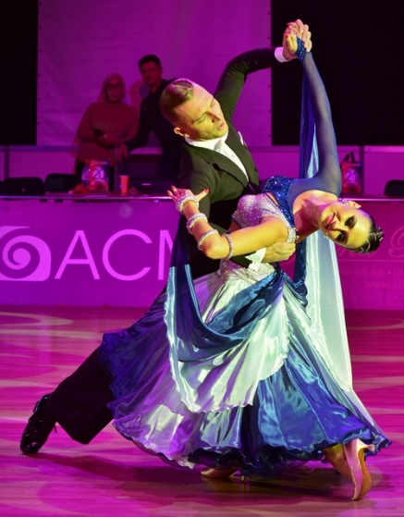

It was a long way of recovery, but I'm back on the floor! In small steps, gradually, first with two crutches, then with one, then limping, but already by myself. Without injections, painkillers and freezing - I listened carefully to my body and did not drown out its pain, accepting it and analyzing at what moments it is the strongest. So I realized that I would not be able to do left pivots for a long time, to climb high on toe, completely transferring my weight to the injured leg. The first week I trained solo, listening to the sensations as much as possible.

I warmed up at the bar (demi plie, releve, battement tendu), repeated the same dance movements many times - descents / ascents, loading legs, rotational movements. During this period, there was a lot of BASIC. Only after I started to dance instead of walk, I moved on to my choreography. But still solo. So, another two weeks passed.

From the very beginning, I did not like the elastic bandage, because the leg lost sensitivity with it. The only thing I used, was salve. But only in extreme cases. I allowed my body to regenerate on its own, naturally.

Of course, after heavy exertion, the leg still swells in the evening, but, nevertheless, I can already train and work at full strength!

During this time, I realized how cool is just to walk, how good is to dance, and how wonderful is when nothing hurts. In everyday life we often forget that the real happiness is - to be healthy!

And so, I'm standing again on a dance floor... And, for the first time in my life, I am not worried at all. My trauma helped me to understand that first of all I dance for myself, which means that it simply cannot be bad and wrong, sharing my performance with the audience and the best partner, who was with me all the time and supported me in the most difficult moments!

P. S. Аnd now, I am looking forward to the first in 2022 year competition in England!

See you there dear friends! Take care of yourself!

With love, Tanya Sopit❤